**Statistical Functions in Excel With Examples**

**Ways to approach statistical function in Excel:**

In Excel, we have a range of statical functions, we can perform basic mead, median mode to more complex statistical distribution, and probability test. In order to understand statistical Functions we will divide them into two sets:

1. Basic statistical Function
2. Intermediate Statistical Function.

**Statistical Function in Excel**

Excel is the best tool to apply statistical functions. As discussed above we first discuss the basic statistical function, and then we will study intermediate statistical function. Throughout the article, we will take data and by using it we will understand the statistical function.

So, let’s take random data of a book store that sells textbooks for classes 11th and 12th.

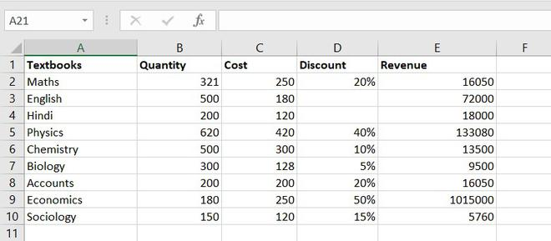

*Example of statistical function.*

**Basic statistical Function**

These are some most common and useful functions. These include the COUNT function, COUNTA function, COUNTBLANK function, COUNTIFS function. Let’s discuss one by one:

**1. COUNT function**

The COUNT function is used to count the number of cells containing a number. Always remember one thing that it will only count the number.

*Formula for COUNT function = COUNT(value1, [value2], …)*

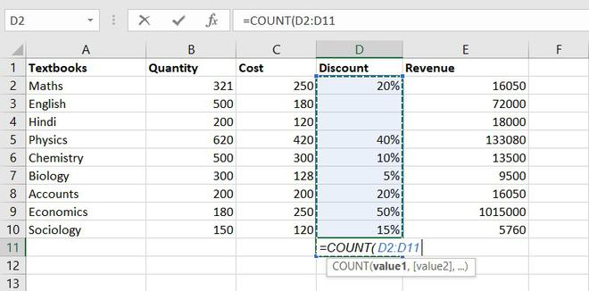

*Example of statistical function.*

Thus, there are **7 textbooks**that have a discount out of 9 books.

**2. COUNTA function**

This function will count everything, it will count the number of the cell containing any kind of information, including numbers, error values, empty text.

*Formula for COUNTA function = COUNTA(value1, [value2], …)*

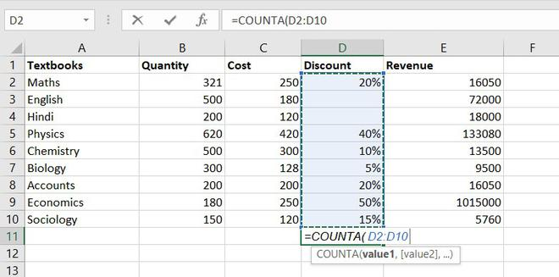

*Example of statistical function.*

So, there are a total of 9 subjects that being sold in the store

**3. COUNTBLANK function**

COUNTBLANK function, as the term, suggest it will only count blank or empty cells.

*Formula for COUNTBlANK function = COUNTBLANK(range)*

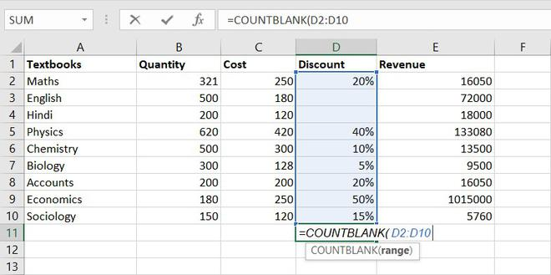

*Example of statistical function.*

There are 2 subjects that don’t have any discount.

**4. COUNTIFS function**

COUNTIFS function is the most used function in Excel. The function will work on one or more than one condition in a given range and counts the cell that meets the condition.

*Formula for COUNTIFS function = COUNTIFS (range1, criteria1, [range2], [criteria2], ...)*

**Intermediate Statistical Function**

Let’s discuss some intermediate statistical functions in Excel. These functions used more often by the analyst. It includes functions like AVERAGE function, MEDIAN function, MODE function, STANDARD DEVIATION function,  VARIANCE function, QUARTILES function, CORRELATION function.

**1. AVERAGE value1, [value2], …)**

The AVERAGE function is one of the most used intermediate functions. The function will return the arithmetic mean or an average of the cell in a given range.

*Formula for AVERAGE function = AVERAGE(number1, [number2], …)*

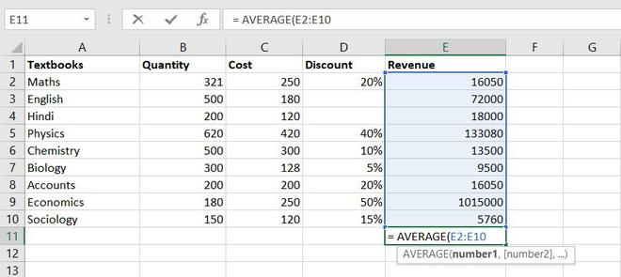

*Example of statistical function.*

So the average total revenue is  Rs.144326.6667

**2. AVERAGEIF function**

The function will return the arithmetic mean or an average of the cell in a given range that meets the given criteria.

*Formula for AVERAGEIF function = AVERAGEIF(range, criteria, [average_range])*

**3. MEDIAN function**

The MEDIAN function will return the central value of the data. Its syntax is similar to the AVERAGE function.

*Formula for MEDIAN function = MEDIAN(number1, [number2], …)*

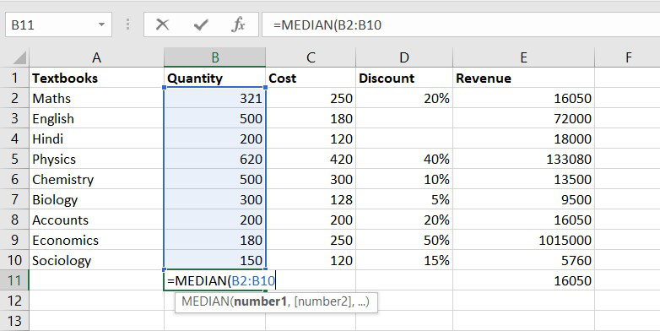

*Example of statistical function.*

Thus, the median quantity sold is 300.

**4. MODE function**

 The MODE function will return the most frequent value of the cell in a given range.

*Formula for MODE function = MODE.SNGL(number1,[number2],…)*

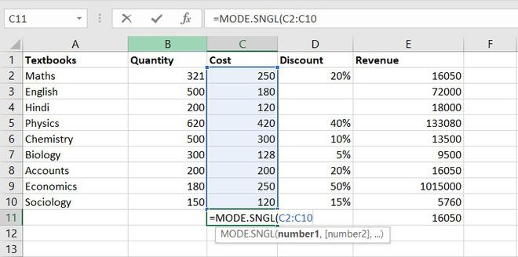

*Example of statistical function.*

Thus, the most frequent or repetitive cost is  Rs. 250.

**5. STANDARD DEVIATION**

This function helps us to determine how much observed value deviated or varied from the average. This function is one of the useful functions in Excel.

*Formula for STANDARD DEVIATION function = STDEV.P(number1,[number2],…)*

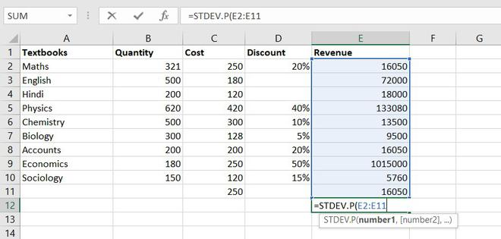

*Example of statistical function.*

Thus, Standard Deviation of total revenue =296917.8172

**6. VARIANCE function**

To understand the VARIANCE function, we first need to know what is variance? Basically, Variance will determine the degree of variation in your data set.  The more data is spread it means the more is variance.

Formula for VARIANCE function = VAR(number1, [number2], …)

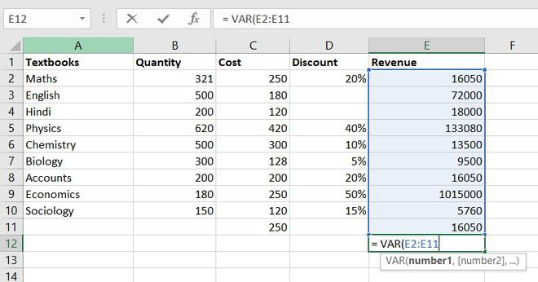

*Example of statistical function.*

So, the**variance**of Revenue= 97955766832

**7. QUARTILES function**

Quartile divides the data into 4 parts just like the median which divides the data into two equal parts. So, the Excel QUARTILES function returns the quartiles of the dataset. It can return the minimum value, first quartile, second quartile, third quartile, and max value. Let’s see the syntax :

*Formula for QUARTILES function = QUARTILE (array, quart)*

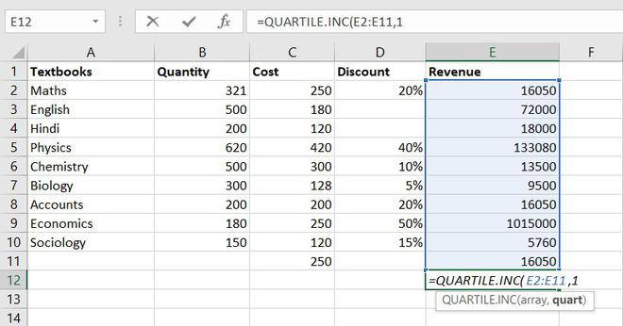

*Example of statistical function.*

So, the first quartile = 14137.5

**8. CORRELATION function**

CORRELATION function, help to find the relationship between the two variables, this function mostly used by the analyst to study the data. The range of the CORRELATION coefficient lies between -1 to +1.

*Formula for CORRELATION function = CORREL(array1, array2)*

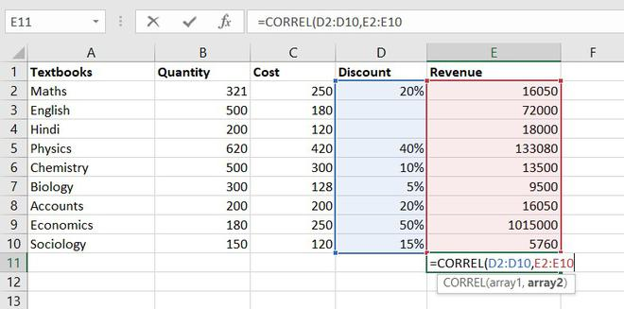

*Example of statistical function.*

So, the correlation coefficient between discount and revenue of store = 0.802428894. Since it is a positive number, thus we can conclude discount is positively related to revenue.

**9. MAX function**

The MAX function will return the largest numeric value within a given set of data or an array.

*Formula for MAX function = MAX (number1, [number2], ...)*

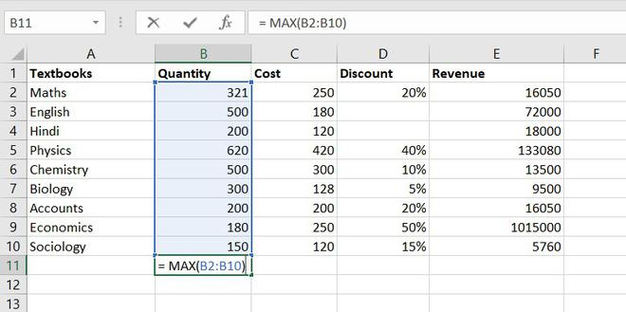

The maximum quantity of textbooks is Physics,620 in numbers.

**10. MIN function**

The MIN function will return the smallest numeric value within a given set of data or an array.

Formula for MIN function = MIN (number1, [number2], ...)

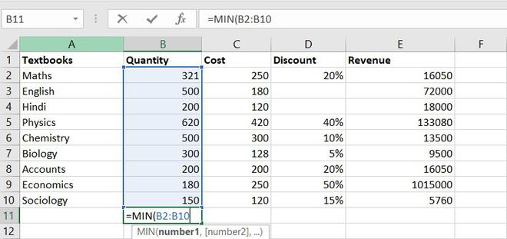

The minimum number of the book available in the store =150(Sociology)

**11. LARGE function**

The LARGE function is similar to the MAX function but the only difference is it returns the nth largest value within a given set of data or an array.

*Formula for LARGE function = LARGE (array, k)*

Let’s find the most expensive textbook using a large function, where k = 1

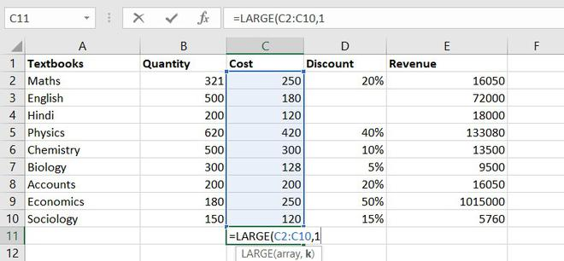

*Example of statistical function.*

The most expensive textbook is Rs. 420.

**12. SMALL function**

The SMALL function is similar to the MIN function, but the only difference is it return nth smallest value within a given set of data or an array.

*Formula for SMALL function = SMALL (array, k)*

Similarly, using the SMALL function we can find the second least expensive book.

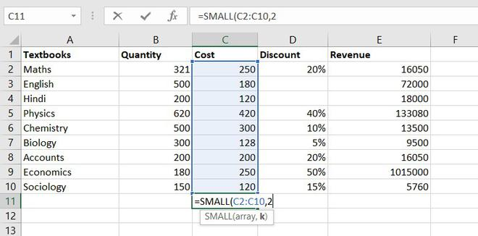

*Example of statistical function.*

Thus, Rs. 120 is the least cost price.

**Conclusion**

So these are some statistical functions of Excel. We have learned some of the most simple functions like COUNT functions to complex ones like the CORRELATION function. So far we learn, we understand how much these functions are useful for analyzing any data. You can explore more functions and learn more things of your own.